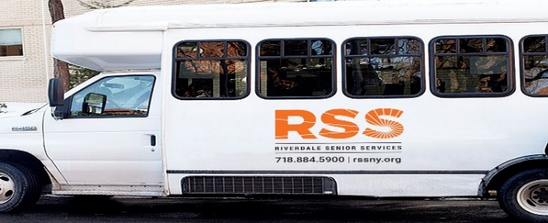
NOVEMBER 2023
CANCELEDWednesday, November 1—El Museo de Barrio-1230 5th Avenue, New York, NY 10029
Leaving 1:00am --Returning 2:00pm Registration begins October 23, 2023 CANCELED
Friday, November 3— Lunch at Dinosaur Bar BQue-700 West 125th Street, New York—
Leaving 11:45am—Returning 1:45pm- Registration begins October 23, 2023
Monday, November 6—Shopping @ Costco-20 Stew Leonard Drive, Yonkers
Leaving 11:15am—Returning 1:00pm Registration begins October 23, 2023
Wednesday, November 8—Tabitha’s Technology Class at Apple Store in B&H Photo—420 9th Avenue, NYC
Leaving 10:30am Returning 12:45pm**THIS IS A TECH CLASS ONLY**
Friday, November 10—Guided Tour at the Jewish Museum—1109 Fifth Avenue, New York, NY
Leaving 10:45am—Returning 1:30pm- Registration begins October 23, 2023
Monday, November 13-Shopping at Stew Leonard-1 Stew Leonard Drive
Leaving RSS 11:15am—Returning 1:00pm
Wednesday, November 15 –Shopping @ Trader Joe—215 N. Central Ave, Hartsdale, NY
Leaving RSS@11:00am Returning 1:30pm
Friday, November 17—Shopping @H Mart –1789 Central Park Avenue, Yonkers
Leaving 11:00am Returning 1:15pm
Monday, November 20—Arthur Avenue-2402 Arthur Avenue, Bronx, NY
Leaving 11:00am Returning 1:00pm
Wednesday, November 22 —Shopping at Kohls—2530 Central Park Avenue
Leaving 11:00—Returning 1:30pm
Monday, November 27—Empire City Casino, 810 Yonkers Avenue,Yonkers, NY
Leaving RSS 10:45am—Returning 1:30pm
THERE IS A $5.00 SUGGESTED CONTRIBUTION FOR THE ROUND TRIP BUS RIDE
On or after November 1, UNLESS OTHERWISE NOTED. please sign up in the office in person
TRIPS ARE SUBJECT TO CHANGE
Please make reservations early. Minimum of six people needed.If there is not enough interest, the trip will be cancelled or rescheduled. If the trip is cancelled for any reason you will be notified and any funds returned.
Thank you for your cooperation.
FUNDED IN PART BY THE AGING.

