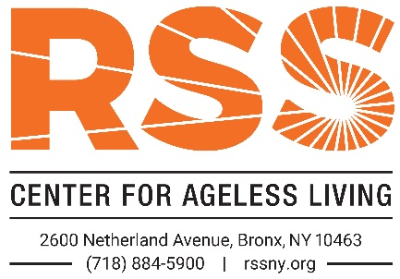 Confidential Planned Giving Intention Form
Name(s): _______________________________________________________ Date of Birth (optional): ____________
Street Address: __________________________________________________________________________________
City: _____________________________________________________________ State: ________ Zip: ____________
Phone: ________________________________ Email: ___________________________________________________
My/Our current intention is to include Riverdale Senior Services (RSS) in my/our Estate Plans:
I/We have named RSS as a beneficiary in my/our will or living trust:
1. RSS’s percentage of the estate is: _________ %. The current monetary value of the gift is $ ___________________.
2. An outright bequest (specific dollar amount) to RSS: $ _________________________
3. Executor/Trustee: _______________________________________________________________________________
Address & Phone: _________________________________________________________________________________
I/We have named RSS as a beneficiary:
1. Of a retirement plan. The administrator is: ___________________________________________________________
2. Of a life insurance policy. The issuer is: ______________________________________________________________
3. Of a bank or investment account. The bank or firm is: __________________________________________________
4. Of a Charitable Gift Annuity, Charitable Remainder Trust, Charitable Lead Trust, or other life income vehicle. The annuity/trust is held at: ____________________________________________________________________________. The current monetary value of this gift is $ ______________
I/We request that RSS use my/our gift for the following purpose:
____ Where Needed Most Other: ________________________________________________________________
I/We retain the right to change my/our mind as the designation of RSS as a beneficiary, as to the purpose of my/our bequest, and as to the portion and amount of my/our estate that will go to RSS.
____ I/We wish to remain anonymous regarding this planned gift.
Signature ______________________________________________ Date ___________________
Signature ______________________________________________ Date ___________________

