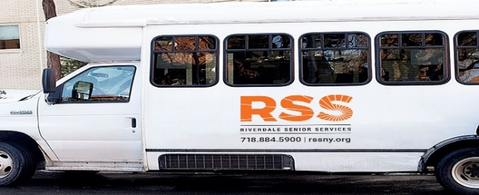
FEBRUARY 2024
Monday, February 5—Shopping @ Costco-20 Stew Leonard Drive, Yonkers
Leaving 11:15am—Returning 1:00pm **REGISTRATION BEGINS TUES JAN. 23**
Wednesday, February 7— Shopping at Macy’s --Cross County Mall—800 Central Park Avenue, Yonkers, NY
Leaving 11:00am Returning 1:30pm**REGISTRATION BEGINS TUES JAN. 23**
**CANCELED**Friday, February 9,—Trip to New Museum-235 Bowery NYC **CANCELED
Monday, February 12-- Shopping at Stew Leonard-1 Stew Leonard Drive
Leaving RSS 11:15am—Returning 1:00pm
Wednesday, February 14— Shopping @ Trader Joe--215 N Central Ave, Hartsdale, NY 10530,
Leaving 11:00am—Returning 1:30pm
Friday, February 16—Lunch @ Dinosaur Bar-B-Que—700 W. 125th Street, NYC 10027
Leaving 11:15am Returning 1:45pm
**CANCELED**Wednesday, February 21—Shopping @ Arthur Avenue-2402 Arthur Avenue, Bronx, NY
Leaving 11:00am Returning 1:00pm **CANCELED
**CANCELED**Friday, February 23, -Lunch @-Seashore Rest—591 City Island Avenue, Bronx, NY
Leaving RSS 11:45am—Returning 2:00pm--**REST. OPENS AT 12PM****CANCELED**
Monday, February 26 The Museum of Broadway 145 W. 45th Street, NYC
Leaving 10:15am Returning 1:00pm
Wednesday, February 28—Empire City Casino, 810 Yonkers Avenue, Yonkers, NY
Leaving 10:45am—Returning 1:30pm
THERE IS A $5.00 SUGGESTED CONTRIBUTION FOR THE ROUND TRIP BUS RIDE
On or after February 1, please sign up in the office in person unless otherwise noted.
Please make reservations early. Minimum of six people needed. Trips are subject to change
If there is not enough interest, the trip will be cancelled or rescheduled.
If the trip is cancelled for any reason you will be notified and any funds returned—.
Thank you for your cooperation.
FUNDED IN PART BY THE NYC DEPARTMENT FOR THE AGING

