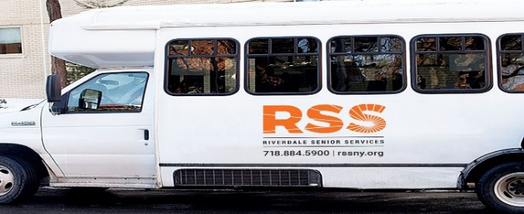
MARCH 2024
Monday, March 4—Shopping @ Costco-20 Stew Leonard Drive, Yonkers
Leaving 11:15am—Returning 1:00pm **REGISTRATION BEGINS TUES FEB 20**
Wednesday, March 6--—Shopping @ Bay Plaza Mall, 2210 Bartow Avenue, Bronx, NY
Leaving 11:00am Returning 1:30pm**REGISTRATION BEGINS TUES FEB 20**
Friday, March 8—Lunch at Chinese Star Buffet-1115 Central Park Avenue, Scarsdale, NY
Leaving 11:00am Returning 1:30pm**REGISTRATION BEGINS TUES FEB 20**
Monday, March 11-- Shopping at Stew Leonard-1 Stew Leonard Drive, Yonkers, NY
Leaving RSS 11:15am—Returning 1:00pm
Wednesday, March 13-- Shopping at Ridgehill Mall,1 Ridgehill Yonkers, NY
Leaving 11:00am—Returning 1:30pm
Friday, March 15—Trip to Rory Dolan Restaurant 890 McClean Avenue, Yonkers, NY
Leaving 11:15am Leaving Rest. 1:30pm
Monday, March 18—Shopping at HMart—1789 Central Park Avenue, Yonkers
Leaving 11:00am—Returning 1:15pm
Wednesday, March 20— Shopping @ Trader Joe--215 N Central Ave, Hartsdale, NY 10530,
Leaving 11:00am—Returning 1:30pm
Friday, March 22—Self Guided Tour @ The Metropolitan Museum of Art-1000 Fifth Avenue, NYC 10028
Leaving 10:15am Returning 1:15pm **THIS IS A SELF GUIDED TOUR TRIP—FREE ADMISSION PROVIDED**
Monday, March 25— Shopping at—Aldi Supermarket, 5532 Broadway, Bronx, NY
Leaving 11:00am—Returning 1:15pm
Wednesday, March 27—Empire City Casino, 810 Yonkers Avenue, Yonkers, NY
Leaving 10:45am—Returning 1:30pm
THERE IS A $5.00 SUGGESTED CONTRIBUTION FOR THE ROUND TRIP BUS RIDE.
Trips are subject to change
On or after March 1, please sign up in the office in person, UNLESS OTHERWISE NOTED
Please make reservations early. Minimum of SIX people needed. If there is not enough interest, the trip will be cancelled or rescheduled.
If the trip is cancelled for any reason you will be notified and any funds returned.
Thank you for your cooperation.
FUNDED IN PART BY THE NYC AGING

